# CLOUD APPLICATIONS DEVELOPMENT

## TOPIC: IMAGE RECOGNITION WITH IBM CLOUD VIRTUAL RECOGNITION

### PHASE 5

TEAM LEADER

S.RITHIK

TEAM MEMBERS

C.SUYAMBURAJ

G.KARTHICKRAJA

L.MOTHIR

N.MADHANKUMAR

MAIN OBJECTIVE OF IMAGE RECOGNITION WITH IBM CLOUD VIRTUAL RECOGNITION

Automated Image Analysis:

The primary goal of the project is to develop a system that can automatically analyze and understand the content of images. This involves identifying objects, scenes, patterns, and potentially text within images.

Classification:

Image recognition systems classify images into predefined categories or labels. For instance, it can determine whether an image contains a cat or a dog, a car or a bicycle, or any other specified categories.

OBJECT RECOGNITION

To identify and classify objects, scenes, or patterns within images, enabling users to gain insights and extract information from visual content.

Enhanced User Experience:

To provide a user-friendly interface that allows users to easily upload images and receive meaningful information or descriptions about those images.

Customization:

The IBM Cloud virtual recognition project might also aim to create a system that can be customized to recognize specific objects or patterns relevant to the project's particular use case.

DESIGN THINKING PROCESS

Empathize:

Understanding user needs and pain points related to image content

Define:

Defining the project scope and objectives.

Ideate:

Brain storming potential solutions, including AI-based image recognition.

Prototype:

Developing a user interface and testing its usability.

Test:

Gathering feedback and refining the project based on user input.

DEVELOPMENT PHASE

Data Collection:

Gathered a diverse dataset of images for training the model.

Training the Model:

Used IBM Cloud Visual Recognition to train the image recognition model. Fine-tune it to improve accuracy and speed.

User Interface Design:

Developed a user-friendly interface for uploading images and viewing recognition results.

Integration with IBM Cloud Visual Recognition:

Integrated the model with IBM Cloud Visual Recognition through their API. Implement features like image upload and result retrieval.

AI Caption Generation:

Implemented a feature to generate captions for recognized images using AI.

Testing:

Tested the application to ensure accurate image recognition and user-friendly experience.

User Engagement Enhancement:

Incorporated AI-generated captions and storytelling features.

Deployment:

Deployed the application to a server or cloud platform.

User Training:

Provided user training and onboarding materials.

Monitoring and Maintenance:

Continuously monitor the application, retrain the model as needed, and perform regular maintenance.

USER INTERFACE

Created an effective user interface (UI) is essential for image recognition project.

Image Upload:

* Allow users to upload images for recognition.
* Support various image file formats (e.g., JPEG, PNG).
* Include a drag-and-drop feature for convenience.
* Show a progress indicator while the image is being processed.

Recognition Results:

* Display recognized labels for the uploaded image.
* Include a thumbnail of the recognized image.
* Add a section for AI-generated captions (if implemented).
* Offer the option to view more details or metadata about the recognition.

Share and Save:

* Enable users to share recognized images and captions on social media.
* Provide options to save images with captions to their device or cloud storage.

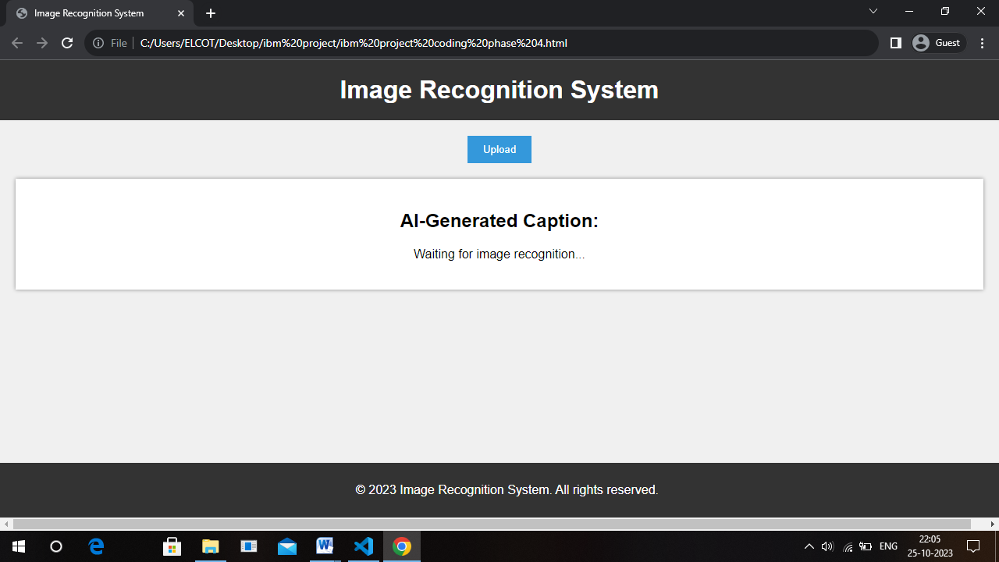

Technical Implementation Details:

* Use a web framework (e.g., Flask, Django) for the backend.
* Implement a frontend using HTML, CSS, and JavaScript for the user interface.
* Utilize the IBM Cloud Visual Recognition API for image analysis.
* Store user data securely and ensure data privacy.
* Host the application on a reliable server or cloud platform.

Integration of IBM Cloud Visual Recognition:

* Sign up for IBM Cloud services and create a Visual Recognition instance.
* Generate API keys and configure the application to authenticate with the Visual Recognition service.
* Use the API to send images for analysis and retrieve recognition results.

AI-Generated Captions:

* After recognizing an image, the AI generates a descriptive caption.
* Captions can be informative, humorous, or tailored to the user's preferences.
* Users can share or use these captions to enhance their storytelling on social media, blogs, or other platforms.

INPUT

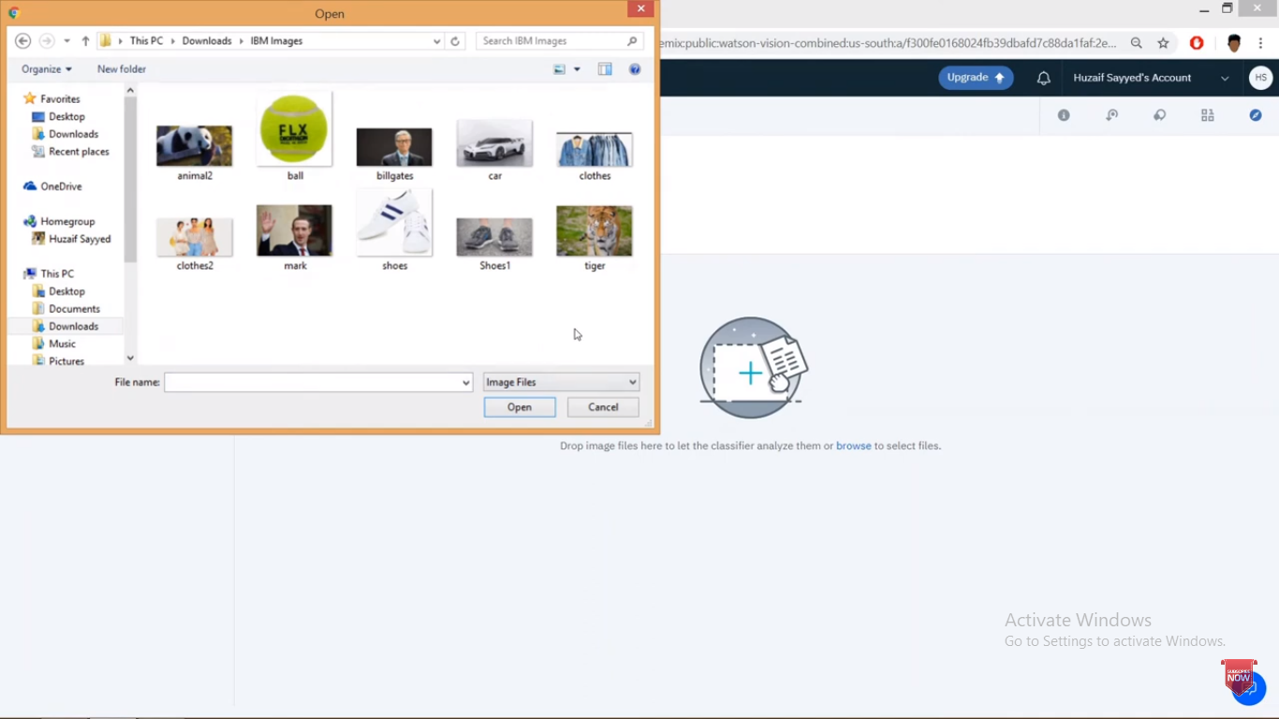

OUTPUT

